First Contact Physiotherapist Practice Educator
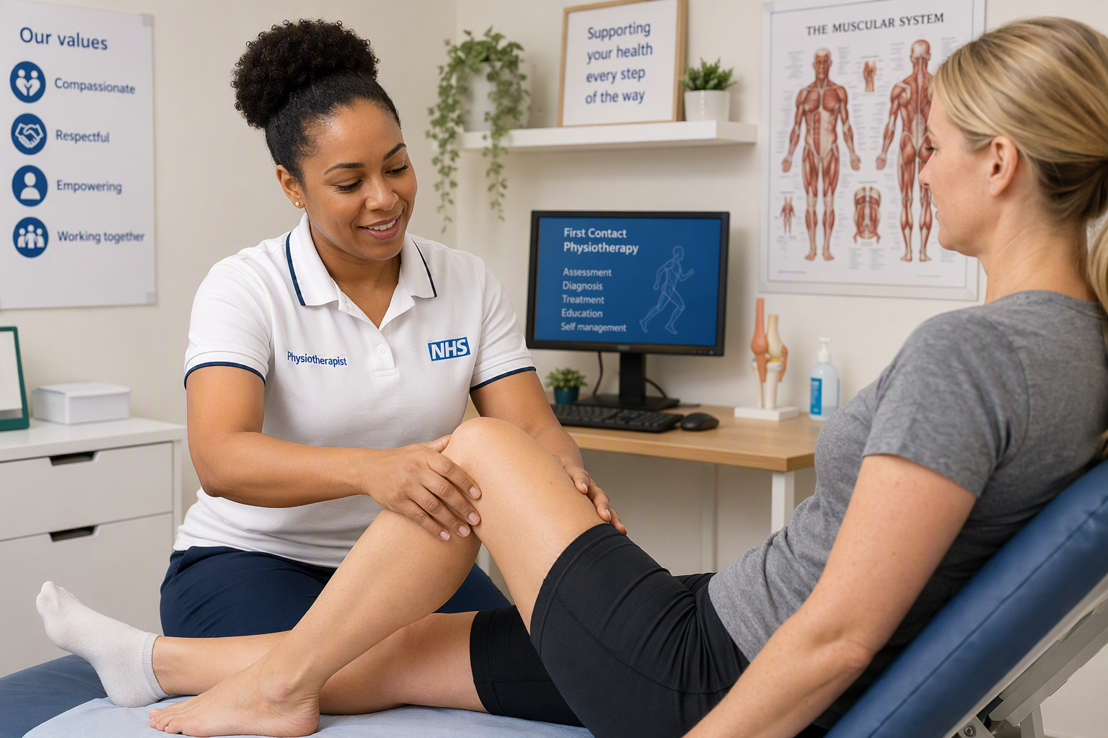

Personal Details - Full name, job title/role, Practice/organisation, years in your profession, years as an educator, email, phone number | Melissa Norman (Nombulelo)  First Contact Physiotherapist  Romsey, North Baddesley and Eastleigh PCN
What motivated you to become a supervisor? | To give something back to the profession.  I enjoy teaching and I find it gives a different dynamic to my day-to-day clinic
What concerns or misconceptions did you have before becoming a supervisor? | I had concerns regarding having difficult students who won’t want to learn or be challenged
How has becoming a supervisor enhanced your own professional development? | I have learned to adapt my practice, my professionalism in order to be exemplary in the eyes of the student
What practical changes did you make to integrate teaching into your practice? | Taking some clinic time off to do induction and halfway meet and final meeting which normally involves a student presentation
Please share a specific example of how your teaching has positively impacted learning? | Students come to this placement with very little knowledge of MSK conditions and MSK pathways, but when they leave, they are empowered with a wealth of knowledge which they will use throughout their career in any setting of physiotherapy
How has having trainees/learners benefited your patients and practice or what unexpected benefits have you experienced through being an educator? | It's been great to have students as they challenge our ways of thinking and ask questions which make us reflect. Patients enjoy being part of someone’s learning journey
What advice would you give to Primary Care staff considering becoming supervisors? | Make sure you have time allocated to catch up at the end of the day.  Create a placement timetable prior to the placement to plan your weeks.  Book a day of shadowing with local community MSK outpatient and also orthopaedic choice so they can follow the pathway through. We have also sent students to our local exercise referral scheme.  This also gives a bit of breathing space in your clinic to catch up with admin etc.
How do you see your role as a supervisor contributing to the future of primary care? | I think this placement is very important in shaping a newly qualifying physiotherapist it offers skills to triage and identify any serious pathologies as well as learning how to manage a lot of MSK conditions. Offering this placement will hopefully make FCP roles desirable to more physiotherapists

