Physiotherapist Practice Educator Case Study
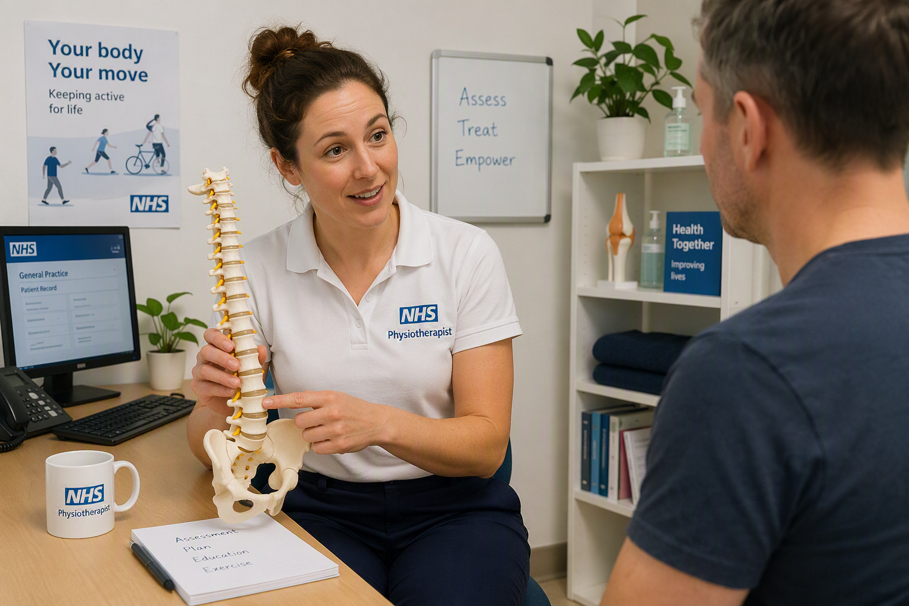
Personal Details - Full name, job title/role, Practice/organisation, years in your profession, years as an educator, email, phone number | Catherine Atkinson  Musculoskeletal Specialist in Primary Care (FCP)
What motivated you to become a supervisor? | We wanted to add another string to our bow and help to educate young Physiotherapists
What concerns or misconceptions did you have before becoming a supervisor? | I was worried about the time it might take and having the responsibility
How has becoming a supervisor enhanced your own professional development? | It’s been great, it makes you think about how you explain things and you also learn new things from the students!
What practical changes did you make to integrate teaching into your practice? | Making sure time is blocked out for induction and halfway/final assessment is very helpful. Also Having catch up breaks for the students to give them more time for note writing and referrals
Please share a specific example of how your teaching has positively impacted learning? | Mel my colleague always gets the students to do a table of each joint, common pathologies and their differential diagnoses. This is always invaluable for the students to take into their working lives.
How has having trainees/learners benefited your patients and practice or what unexpected benefits have you experienced through being an educator? | It’s been great to get a perspective on physiotherapy and life in general from younger people, especially the different digital world they live in compared to when I was a student.
What advice would you give to Primary Care staff considering becoming supervisors? | If you manage your diary appropriately then having students in Primary Care shouldn’t change your day at all.
How do you see your role as a supervisor contributing to the future of primary care? | I think undergraduate knowledge of Primary Care is so important to widen your knowledge of many medical conditions that could be masquerading as an MSK problem. I’m hoping we will inspire the future generations to become FCP’s to alleviate pressure on GP’s.

