Accent Leave Manager User Guide (Applicants) v2.0
- GETTING STARTED

For postgraduate doctors and dentists in training there is an interface process between the NHS England (NHSE) Trainee Information System (TIS) and Accent Leave Manager (ALM). This process means that if you are in a current training programme you will already have an Accent Leave Manager account.

- LOGGING IN

The Accent Leave Manager system can be accessed online via the Accent portal which can be found at: https://accent.hicom.co.uk/Portal/Live/Web

If you already have your credentials (your email address is the same as your TIS/TSS registered email address) you can log in from the home page.

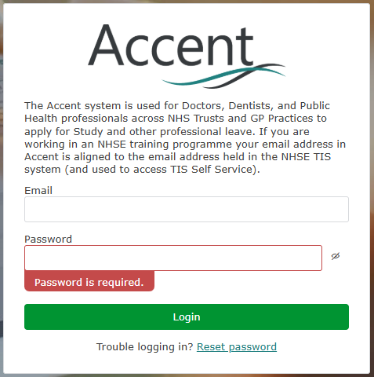

- RESETTING YOUR PASSWORD

If you do not know, or have forgotten, your password you can reset it from the homepage too. Select “Reset password” to be navigated to the below page, input your registered TIS/TSS email address and press “Reset Password”. You will receive an email with a link to allow you to change your password.

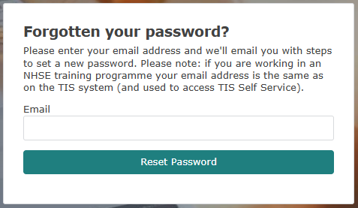

- ACCENT PORTAL

Once you have logged into the system you will be taken to the Accent Portal, this area provides you links to your account in the top right corner as well as tiles on the main screen allowing navigation to different parts of Accent Leave Manager. The menu items on the left will also allow navigation to the parts of the system to which you have been granted access.

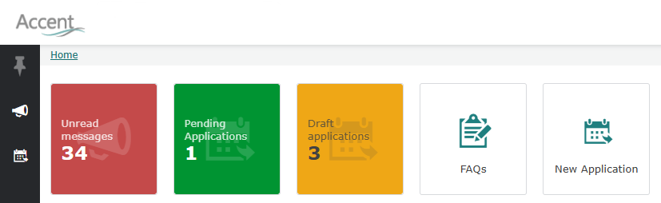

- NEW APPLICATION

The New Application tile will immediately navigate you to a new, blank leave application form. This is the first step in applying for leave.

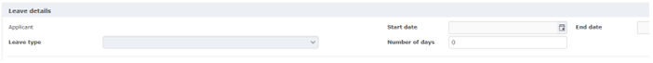
Input your leave start and end dates, correct the calculated number of days leave if necessary.
Select the placement you are applying against – If there is only one it will be auto selected.
Select Leave type – International (if offered) or regular Study leave.
Save the details – Please note it is not possible to change these details after this point. If dates, leave type, or placements need to be changed a new application must be created.

- EVENT DETAILS

You are required to enter your Event and Course reference details. These fields are mandatory, but you can enter N/A is if there is no Course reference. Venue, Venue Postcode, Provider, Website, and Supporting Information are optional (but useful if you can enter them). Mandatory fields are marked with an asterisk.

Documents can also be uploaded in this section which relate to the application. If your region requires it you should upload evidence of your Educational Supervisors support for your application, and any other useful information (eg course agenda).

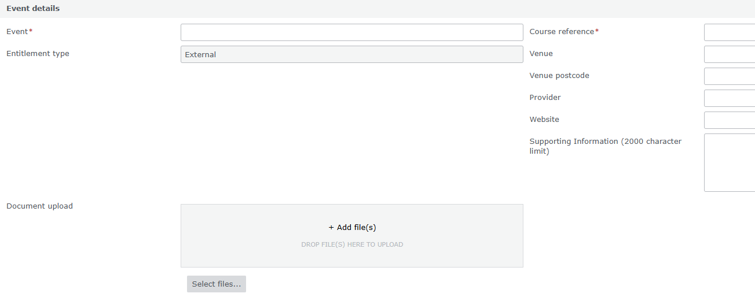

- ENTITLEMENTS AND BUDGETS

The Entitlement and Budget section will display the details of study leave days and expenditure taken from your entitlement and budget respectively.

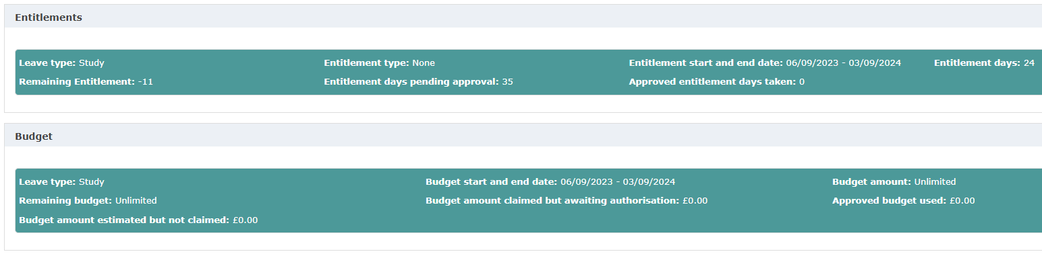

The available entitlements and budgets are displayed based on the dates you’ve selected. Select the appropriate entitlement and budget, where there is only one the system will automatically select it for you. If the system does not display an entitlement or budget, please contact the Accent Leave Manager Support team (england.imsupport.south@nhs.net), who will add an entitlement and budget for you.

- COVER & AUTHORISATION

You are required to complete the Cover and Authorisation section. Mandatory fields are marked with an asterisk, you must acknowledge the Self Declaration by switching the toggle to Yes.

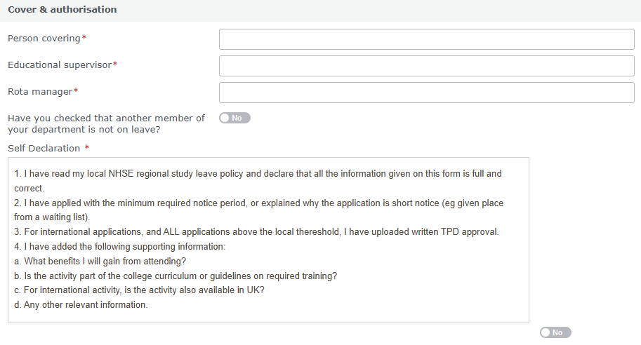

- EXPENSES

You should add estimates for any expenses you expect to incur and reclaim as a consequence of taking this study leave. These estimated expenses are to support your application for leave, they will not automatically result in reimbursement, nor should the approval of the study leave be taken as confirmation that the expenses will be reimbursed. Expenses should be reclaimed according to your Trusts’ policy and local process. Receipts do not need to be uploaded onto the Accent system.

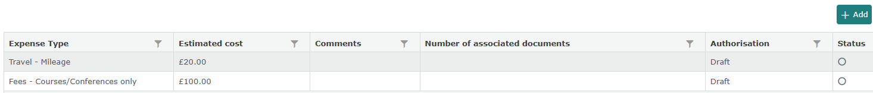

- SUBMITTING LEAVE

Once your application is complete and you have provided all mandatory fields you are able to submit your application. Doing so will trigger the system to create an approval chain for your application, this is a list of people who are required to approve your application. After you have submitted your leave application you can access it at any time via the My Applications menu item.

- APPROVAL CHAIN

Once your application is submitted you are able to see the list of required approvers at the bottom of the page and also the status of their decision i.e. who the application is currently sitting with for approval. You are able to message the approver that the application has reached (using the envelope icon), or everyone at a particular sequence. You many also download a PDF copy of the application or copy the application as a draft to create another application.

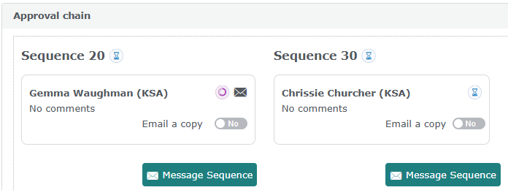

- CANCELLING LEAVE

If you have submitted an application, which you subsequently want to cancel, you can do this from within the leave application. If your application has been partially or fully approved, the cancellation request will also go through the approval chain. You cannot cancel leave that is in the past.

