2026 Wessex Medical Educators’ Forum,
Welcoming Educators across the South East

Tuesday 3 February 2026

Venue: Explorer House, Southampton & MS Teams

09:15 | Registration and refreshments
09:45 | Welcome | Dr Phil Rushton  Locality Dean – Wessex
10:00 | AI & Health Education | Dr James Wei Wang  Consultant Clinical Oncologist  Vernon Cancer Centre  Clinical Digital Lead, AI Special Interest Group Lead, RCR Clinical Oncology Committee
10:30 | CEO of OS "inspiring careers" | Nick Bolton  Chief Executive Officer, Ordnance Survey
11:15 | Refreshments and move to Workshops
11:45 | Workshop 1
A | Simulation & TEL updates | Dr Matt Williams  Associate Dean, Wessex Deanery  Consultant Intensivist, Portsmouth Hospitals; Vice-Dean, Faculty of Intensive Care Medicine
B | Enhancing Training: AI for Learners and Educators | Dr Jonathan Rial  GP Associate Dean - NHS England  RCGP Training Portfolio Clinical Lead
C | Flexible working: promises for the new workforce or challenges for the existing one? | Guhavarma (Guhan) Viswesvaraiah  Associate Dean - NHS England  Consultant Acute and General Physician, University Hospital Southampton NHSFT
D | Bridging the gaps in Intensive Care Medicine through Reverse Mentorship | Dr Matt Rowe  Consultant Intensive Care Medicine and Anaesthesia  North Bristol NHS Trust  Faculty Tutor ICM, Former FICM Board Member (Trainee Representative)
E | Acceleration of Training | Dr Sue Brock  Associate Dean  NHSE Wessex  Consultant Clinical Oncologist, UHD
12:30 | Lunch and move to Workshops
13.30 | Workshop 2 | Same topics as Workshop 1
14:15 | Fellows presentations | Dr Andrew Sills  Specialist training registrar in Respiratory Medicine, General Internal Medicine, and Intensive Care Medicine  Wessex point of care ultrasound fellow  Queen Alexandra Hospital, Portsmouth  Dr Sarah Westmore  GP  St Helens Medical Centre, Isle of Wight  Dr Rory Ormiston  Orthopaedic Specialist Registrar  University Hospitals Southampton NHS FT
15.00 | Refreshments
15.15 | Social Media as Healthcare Professionals & How We Engage With The Public | Dr Brooke Vandermolen (virtual)  Clinician Content Creator (Womens Health) @theobgynmum  ST6 Obstetrics & Gynaecology Registrar UCLH (NET deanery)
15.45 | Summary and Close | Dr Phil Rushton  Locality Dean – Wessex
16:00 | Close

Biographies
James Wang | I am a Consultant Clinical Oncologist specialising in neuro-oncology and uro-oncology, with a parallel leadership role as Digital Lead for Cancer Services at Mount Vernon Cancer Centre within East and North Hertfordshire NHS Trust. My clinical practice spans radiotherapy and systemic therapies, alongside active involvement in clinical trials and service development across a hub-and-spoke cancer network. I lead on digital transformation initiatives, including electronic health record implementation, research-ready routine data, and the development of AI-enabled workflows to support audit, workforce planning, and real-world evidence generation. My academic interests focus on applied clinical AI, imaging biomarkers, and translational digital infrastructure, and I contribute to national AI governance and educational activity through committee work, conference leadership, and collaborative research.
Nick Bolton  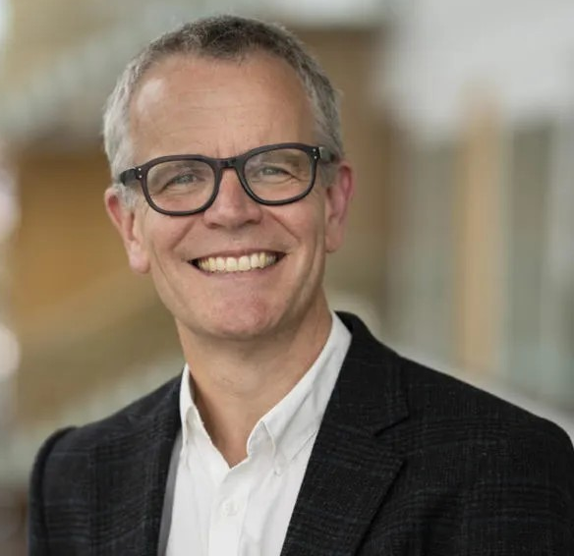 | Nick joined Ordnance Survey as CEO in October 2023, with extensive commercial, product and marketing experience in growing international technology businesses. As Chief Executive Officer, Nick is responsible for executing the OS strategy and leading the organisation as world leaders in geospatial services, creating location insight for positive impact.  Previously, Nick was CEO for software group Oxford Metrics for 18 years. His strong track record in successfully leading teams and delivering strategic priorities, alongside driving development in both existing and new markets, is helping shape OS’s future growth.
Matt Williams  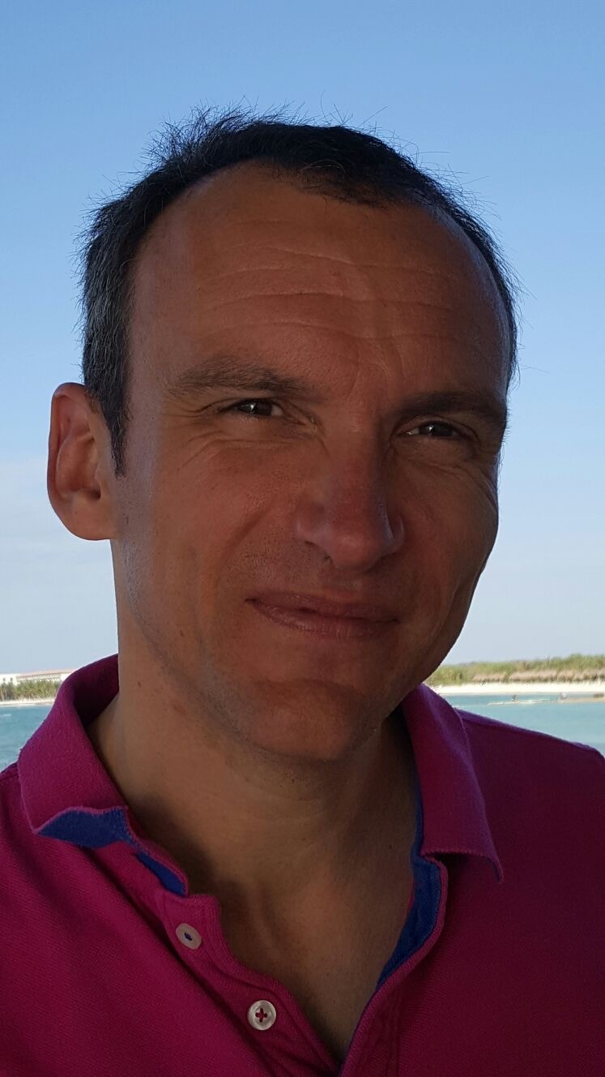 | I have been a Consultant in Critical Care and Anaesthesia at Portsmouth Hospitals University NHS Trust since 2005, following medical school at Bristol University and postgraduate specialist training in the South West and Wessex regions that included overseas posts at the Alfred in Melbourne, Australia and at the University of Michigan. My professional interests are in medical education, ethics, and patient safety.  I first experienced high fidelity simulation when attending a crisis resource management course as a registrar for anaesthetics emergencies. I have been interested in simulation ever since! Having spent several years delivering simulation training for anaesthesia, Foundation and acute care specialities, I was appointed clinical director of the Simulation Centre at Portsmouth Hospitals (2011-2021). In 2021, I was appointed to an Associate Dean post to oversee the simulation, technology enhanced learning, patient safety and QI portfolio. I am a firm believer that simulation has a place to support training; but it needs appropriate training and understanding to deliver effectively.
Jonathan Rial  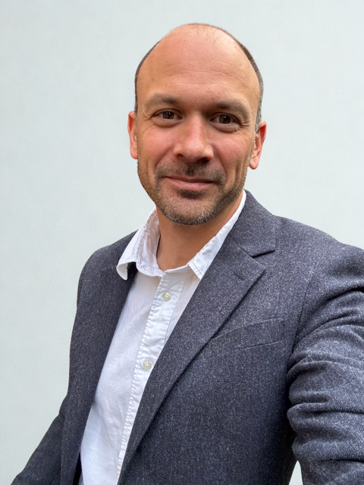 | Jonathan Rial is a GP Educator with roles as Associate Dean and Programme Director as well as Clinical Lead for the trainee Portfolio at the RCGP. He leads work on developing and improving digital platforms for training and assessment, with a particular focus on the role of AI in medical education.
Guhavarma Viswesvaraiah  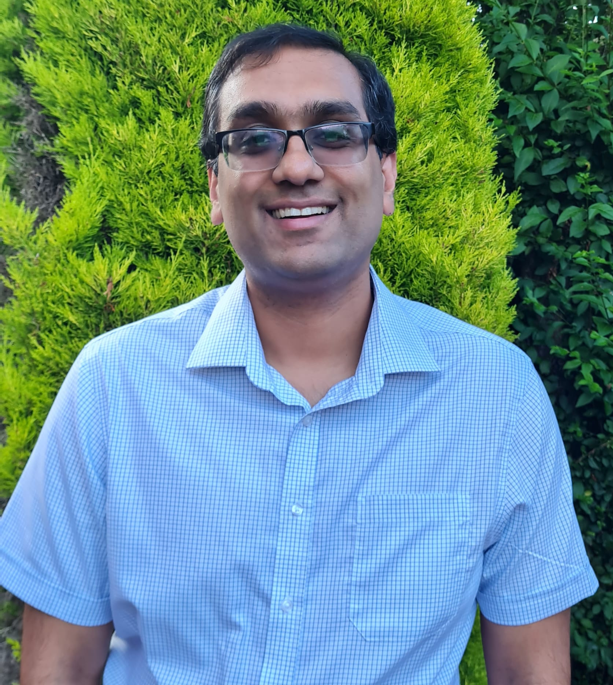 | I am one of the Associate Deans in NHS Wessex and Southeast, with a portfolio that encompasses LTFT, OOP, Flexible portfolio training, Fellowships, Induction, Differential Attainment, and relocation expenses. I am also the link Associate Dean for the Schools of Surgery and Emergency Medicine.  I have recently taken on a role regarding Improving Doctors Working Lives across the South East, working to implement the 10-point plan and recommendations of the Postgraduate Medical Training Review.
Matt Rowe  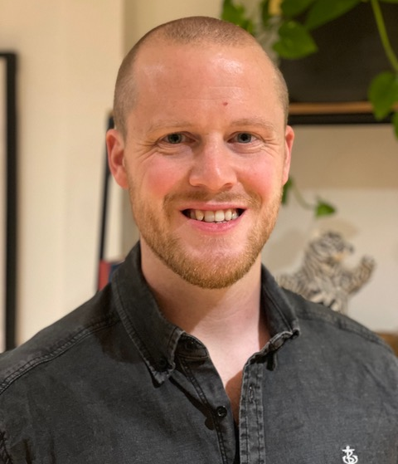 | I am a Consultant in Intensive Care Medicine and Anaesthesia at Southmead Hospital in Bristol. I’m a Faculty Tutor for ICM and during training, held a position on the FICM Board as a Trainee representative. I have special interests in Trauma, Neuro-intensive care, Medical Education and Leadership.  Outside of work, I enjoy Mountain Biking, Snowboarding and almost all outdoor pursuits. I’m also an enthusiastic drummer.
Sue Brock | After training in Cambridge and Oxford, Sue moved to the South Coast as has worked here ever since. Her Clinical Oncology training was based at Southampton, with a year's fellowship in the USA. She was appointed as a consultant uro-oncologist at UHD in 2005. During her career she has held a variety of educational and resident-doctor facing roles, including Guardian of Safe Working, TPD and Deputy Head of School for Medicine. She has also held positions within the RCR.  Sue has been an Associate Dean at Wessex for 3 years; her portfolio includes ARCP management as well as working with the PDU team delivering resident doctor courses and study leave allocations.  Outside of work she enjoys being out and about in the New Forest, running, cycling, swimming and long-distance walking.
Rory Ormiston  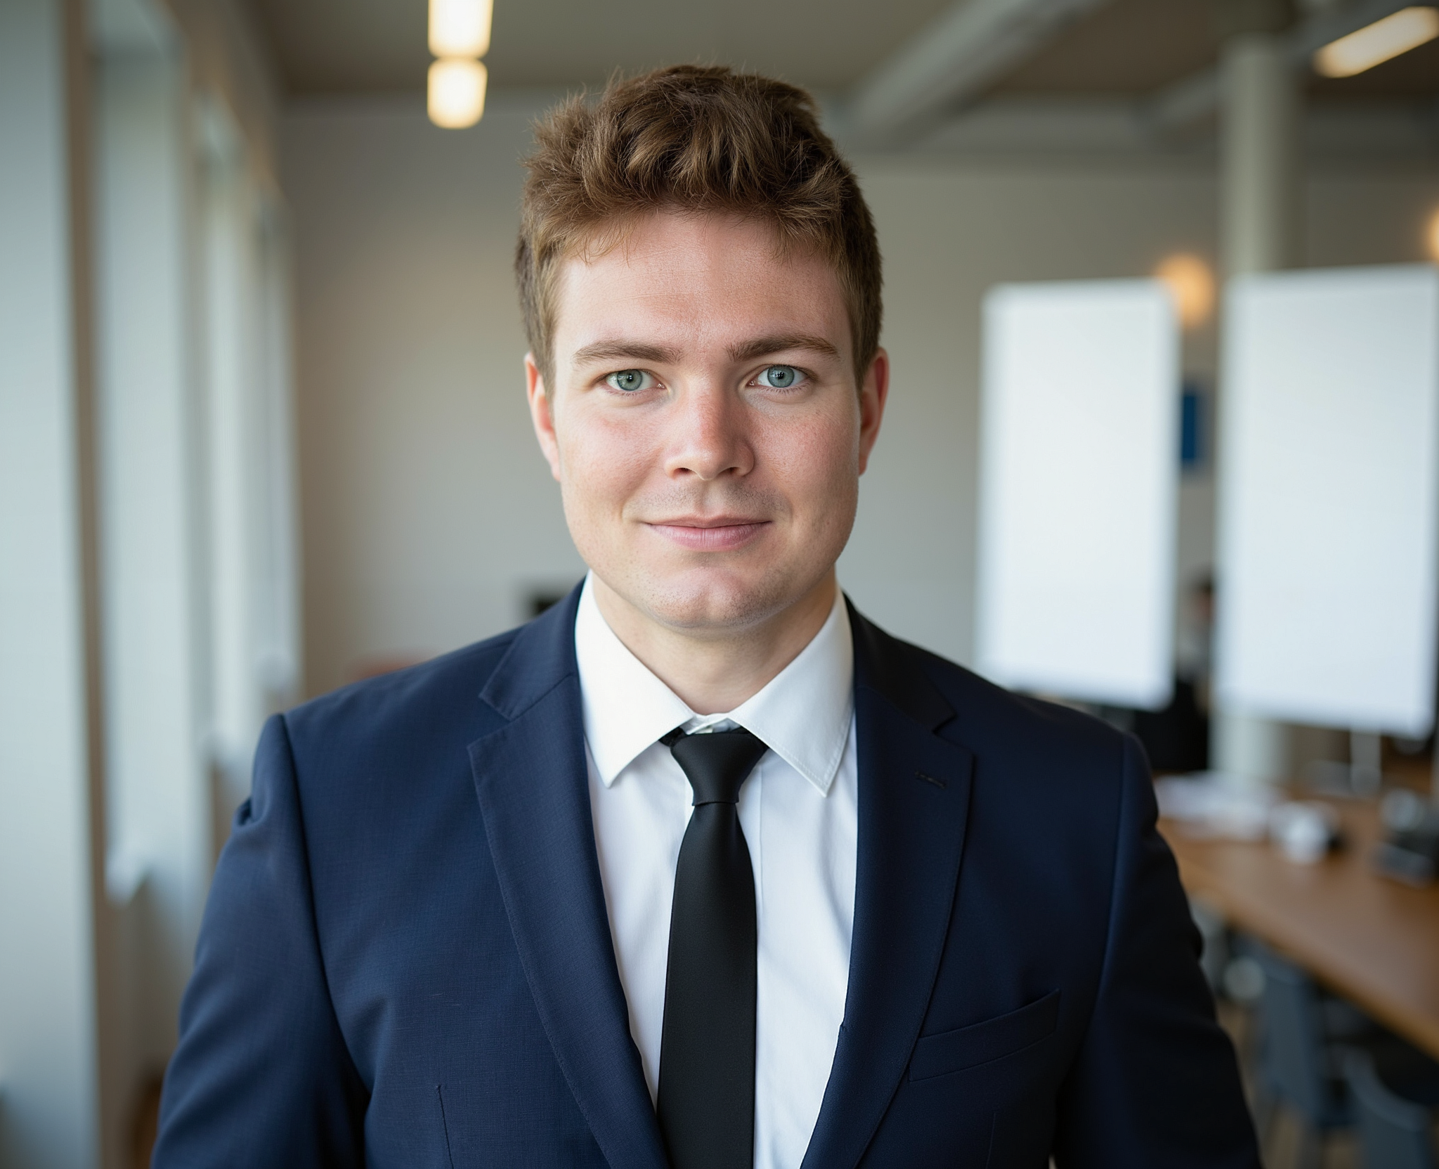 | Rory Ormiston is a Trauma and Orthopaedic Registrar in the Wessex Deanery and a current PhD candidate at the University of Southampton, where his research focuses on the application of artificial intelligence to surgical decision-making. Having commenced his doctoral studies in 2024, he is developing expertise at the intersection of perioperative care, predictive modelling, and digital health innovation.  Rory is currently an NHS Fellow in Clinical AI, he has experience as an NIHR Associate Principal Investigator for the PROFHER2 trial and in 2024 was awarded a Gwen Fish Research Grant to advance AI-driven image recognition in orthopaedics.  Rory holds a Masters in Medical Education, is an ATLS instructor and a Fellow of the Higher Education Academy.
Andrew Sills  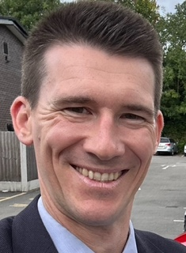 | Andrew Sills is a triple-accrediting Specialist Registrar in Respiratory Medicine, General Internal Medicine, and Intensive Care Medicine, with particular interests in point-of-care ultrasound (POCUS), clinical leadership, and governance.  He completed his undergraduate medical training in Edinburgh, followed by Foundation and ACCS–Acute Medicine core training in Manchester. After core training, he spent two years in New Zealand working as a Medical and Intensive Care Registrar, further developing his interests in acute and critical care.  He returned to the UK in August 2021 to commence higher specialist training, initially in Intensive Care Medicine and subsequently in Respiratory and General Internal Medicine. Throughout his career he has maintained a strong interest in POCUS as a contemporary tool to enhance diagnostic accuracy and patient care. He is a FUSIC Heart mentor and, in 2025, undertook a one-year fellowship focused on developing POCUS training across the Wessex region.
Sarah Westmore  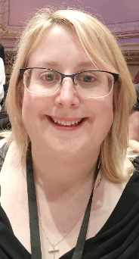 | I am a GP on the Isle of Wight with a special interest in learning disabilities and autism. My undergraduate and postgraduate training was in Birmingham and the Black Country before I moved to the Isle of Wight in 2014.  My qualifications and experience include a PGCert in Medical Education 2020 University of Winchester  MSc Learning Disabilities (and autism) 2023 University of Portsmouth. NHS Wessex Health Equality/ Trailblazers Fellowship 2024-25.  I am involved in a number of groups and organisations focusing on health inequality, particularly within the learning disability and autism population. I teach Medical Students at Portsmouth University , focusing on topics around health equality.
Brooke Vandermolen   | Dr. Brooke Vandermolen is an Obstetrics and Gynaecology registrar with a special interest in paediatric and adolescent gynaecology. She has completed a fellowship at University College London Hospitals and conducted research on premature ovarian insufficiency. In addition to her clinical work, she has completed a foundation course in Digital Health Leadership at Imperial College London. She is an experienced medical writer, and creates digital content for the Royal College of Obstetricians and Gynaecologists (RCOG) and NHS England to translate trending topics into evidence-based, relatable bite-sized media.  She is also the current trainee representative for the British Society for Paediatric and Adolescent Gynaecology (BritSPAG) and UCLH O&G department.  Outside of her clinical and academic achievements, Dr. Vandermolen is a prominent figure on social media, where she uses her platform to promote women’s health education. She engages a broad audience through her blog The OBGYNMum, and social media profiles, @theobgynmum on instagram, Tiktok and Youtube. She uses her platforms to share evidence-based insights into topics from pregnancy, periods, fertility, menopause and more. As part of her online presence, she regularly works with global tech organisations such as Google, YouTube and Tiktok on their Clinican Creator councils, helping these organisations to bring accurate, accessible medical information to the public.

