**Interview Preparation for the Student Nursing Associate**

**What are the interview panel looking for?**

* That you understand the aim, purpose and requirements of the role and the course
* That you have the skills attributes and qualities necessary to perform the role and complete the demands of the course
* clear and effective communication
* good decision making
* teamwork
* adaptability
* That you are aware of the challenges of the course
* That you understand once qualified, the role is registered by the nursing and midwifery council
* Most importantly, that you have the personal values required of a nurse

**Useful reading**

[Introducing the 6 Cs](https://www.england.nhs.uk/6cs/wp-content/uploads/sites/25/2015/03/introducing-the-6cs.pdf)

[NMC – Nursing Associates](https://www.nmc.org.uk/about-us/our-role/who-we-regulate/nursing-associates/)

[Freedom to speak up](https://www.hee.nhs.uk/our-work/freedom-speak-guardians)

**Watch:**

There are useful videos that support with application and interview preparation for example:

[Interview Tips for a Trainee Nursing Associate Apprenticeship - YouTube](https://www.youtube.com/watch?v=S_WL-0w3A2s)

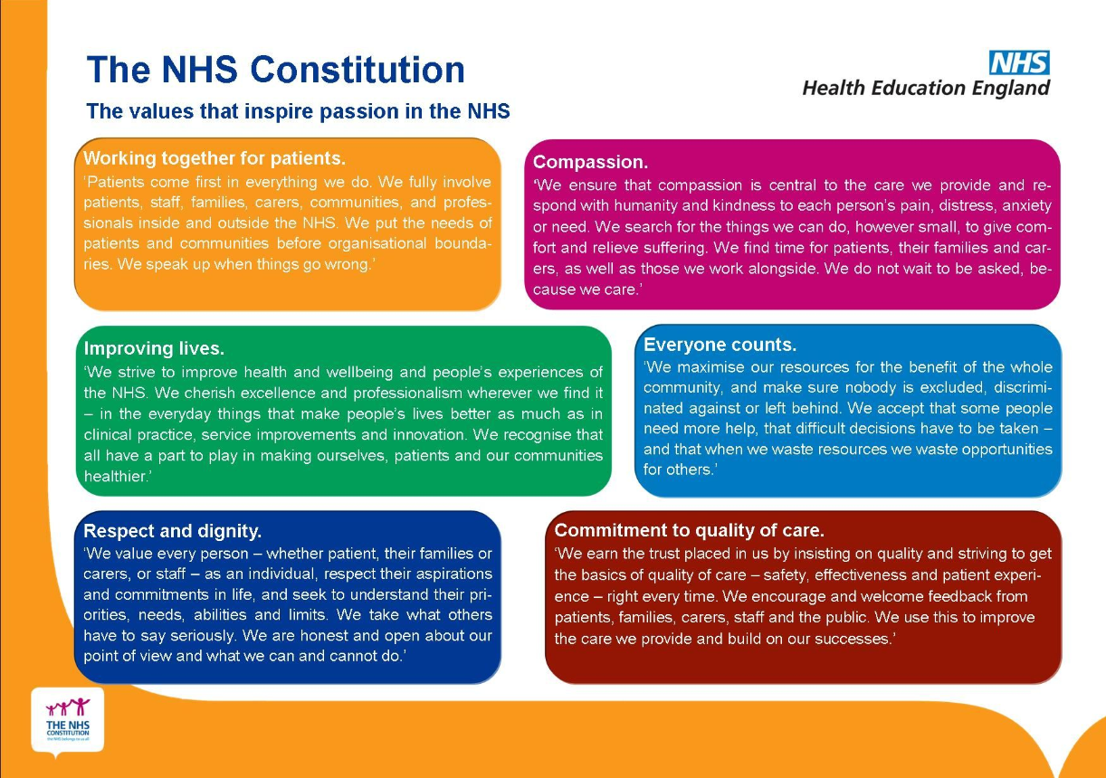

**Example questions**

* Tell us about yourself, what previous experience do you have and why do you want to become a nursing associate?
* What are the personal values you will bring to the profession, how you have seen or used these within your current practice?
* The nursing associate role is new to primary care – how will you champion the role and help it be understood in your Practice, Primary Care Network and across the Integrated Care Board?
* How will you prepare for the academic and practice demands of the course?
* What is your understanding of the role?

To answer this question you'll need to have read the job description and

person specification thoroughly:

* Look at the job purpose or aim, and the duties and responsibilities you'd be required to carry out.
* Work out how your role would fit within the organisation, and the impact it has on any other teams or services.
* What are the most important skills and attributes needed to perform this role successfully?

**What employers are looking for:**

* That you understand the aim, purpose and requirements of the role
* Whether you've researched the role properly
* Whether you have the skills, attributes and qualities necessary to perform this role
* That you are aware of any challenges, limitations or expectations involved

**Scenario questions**

* Can you give me an example of when you have been caring? What was this like for you?
* What would you do if a senior colleague told you to do something you're weren't trained to do?
* What would you do if you overheard a senior colleague making inappropriate comments to a patient.
* What would you do if you witnessed a nurse administering an incorrect drug?

With questions like this, employers will want to know that you have common sense, good judgement, and that patient safety and wellbeing are your priorities.

They may also look to see whether you encompass the 6Cs, (Care, Compassion, Competence, Communication, Courage, Commitment.) or their own organisational values where applicable.

**What employers are looking for:**

* An assessment of the situation
* That appropriate action was taken
* Whether procedures, policies, guidelines or codes of practice were adhered to
* Appropriate communication
* Record keeping
* Evaluation and learning

**Further resources**

[Sample interview questions for nurses and HCAs | Careers resources | Royal College of Nursing (rcn.org.uk)](https://www.rcn.org.uk/professional-development/your-career/interviews/sample-interview-questions)