2025 Medical Educators’ Forum, hosted by Wessex
Supporting a Diverse Workforce

Wednesday 22 – Thursday 23 January 2025

Venue: Explorer House, Southampton & live-streamed

Day 1 - Wednesday 22 January 2025

09:15 | Registration, refreshments and networking
09:30 | Welcome | Dr Paul Sadler  Postgraduate Dean - Wessex and Thames Valley;  Regional Dean, NHS England – South East
10.00 | Meet the Team | Various Deanery representatives
10:20 | Refreshments
11:00 | Increasing Capacity to meet the Long- Term Workforce Pan | Dr Paul Sadler  Postgraduate Dean - Wessex and Thames Valley;  Regional Dean, NHS England – South East
11:45 | Educator Workforce Strategy | Dr Asif Ali  Associate Dean, Education and Development, NHS England - Thames Valley
12:30 | Lunch and networking
13:30 | Keynote speaker:  Learning from other Health Systems - if the grass really is greener, how do they do it? | Professor Peter Hockey  Academic Director of the Clinical and Professional Development Unit, Faculty of Medicine and Health, The University of Sydney;  Director of Education within Western Sydney Local Health District
14:30 | Innovative Training | Dr Rachel Elliott  GP Associate Dean Portsmouth and Isle of Wight (job share)  Dr Bryony Sales  GP Associate Dean Portsmouth and Isle of Wight (job share)
15:10 | Refreshments
15:30 | Returning To A Career In Medicine -  Breaking Barriers: Broad shoulders, Thick skin | Dr Saika Hussain  Specialty Doctor  West Hampshire Community Diabetes Service  HIOWH  Dr Kate Fayers  Consultant Diabetologist  Training Programme Director - Wessex  Dr Hermione Price  Consultant Diabetologist and Honorary Senior Clinical Lecturer (University of Southampton);  Deputy Head of School of Medicine, NHS England - Wessex
16.10 | Differential Attainment - where are we now and how far have we come? | Dr Guhan Viswesvaraiah  Associate Dean, NHS England – Wessex  Dr Katie Collins  GP Lead for DA, NHS England – Wessex  Anjali Mavi  IMG Welfare Officer – Wessex  Laura Ramundo  IMG Welfare Officer - Wessex
16.50 | Summary of Day 1 and Close

Day 2 - Thursday 23 January 2025

09:15 | Registration, refreshments and networking
09:30 | Welcome back & recap | Paul Sadler  Postgraduate Dean - Wessex and Thames Valley  Regional Dean, NHS England – South East
09:40 | Update on Undergraduate Medical Education | Clare Polack  Professorial Fellow in Medical Education, University of Southampton;  Southampton GP
10:20 | Presentations from Fellows | Dilan Sanli  Miju Lee  Sam Montandon  Henry Harcourt
11:00 | Refreshments and move to Workshops
11:30 | Workshop 1
A | The Safe Learning Environment Charter - What's it all about and what does it mean for you | Katie Castle  Education Quality Lead in Practice Learning, NHS England - South East  Caroline Lee  Head of Education Quality, NHS England – South East  Dr Helen O'Reilly  Associate Dean, Wessex Primary care Training Hub, NHS England – South East
B | Genetics/Genomics | Jessica Williams  Principal Genetic Counsellor  Wessex Clinical Genetics Service  Imogen Cummings  Genetic Counsellor  Wessex Clinical Genetics Service  Michael Carter  Genomic Clinical Nurse Specialist  Wessex Clinical Genetics Service
C | Generational differences – how is learning as a doctor affected? | Dr Mike Masding  Co-Chair, UK Foundation Programme Office
D | Neurodiversity | Dr Antonia Calogeras  Associate Dean, NHS England – South East
E | Developing multi-professional clinical education leaders | Dr Mary-Rose Shears  Primary Care Dean, Thames Valley and Wessex, NHS England – South East  Kat Hall  Pharmacy Dean South East (TVW and KSS
F | Supporting International Medical Graduates | Dr Julie Onslow, Associate Dean, NHS England – Wessex  Anjali Mavi  IMG Welfare Officer – Wessex  Laura Ramundo  IMG Welfare Officer - Wessex
12:30 | Lunch and networking
13:30 | Workshop 2 | Same Topics as Workshop 1
14:30 | Refreshments and return to main room
15.00 | Keynote speaker 2:  Transforming tomorrow – Celebrating SAS Excellence and pioneering the LED Blueprint for change’ | Professor Geeta Menon  National Clinical Lead for workforce for Cancer and Diagnostics & National Dean for Inclusive Integrated Careers, NHS England – Workforce, Training and Education Directorate;  Consultant Ophthalmic Surgeon
16.00 | One big thank you | Dr Julie Onslow, Associate Dean, NHS England - Wessex
16.10 | Summary | Dr Paul Sadler  Postgraduate Dean - Wessex and Thames Valley;  Regional Dean, NHS England – South East
16.30 | Close

Biographies
Dr Asif Ali

Associate Dean, Education and Development, NHS England - Thames Valley

  Professor Peter Hockey  DM FRCP (London) FRCP (Edin) FRACP  Executive Director Quality & Safety  Western Sydney Local Health District;  Honorary Clinical Professor, Sydney Medical School  University of Sydney | Prof. Peter Hockey is a leader in healthcare education, quality and patient safety, and workforce development.  He has had experience in South Africa, USA, UK and Australia. Peter accepted his current appointment as the Executive Director of Quality and Safety at the Western Sydney Local Health District (WSLHD) in 2023, where he leads the governance of quality, patient safety, clinical risk management, clinical education, clinical research and the NSW Statewide Health Literacy Hub; following his tenure as the Director of Education at WSLHD since 2019.  Prior to his appointments in Sydney, Peter was a Consultant Respiratory Physician and Postgraduate Dean for Health Education England (Wessex). A former Harkness Fellow at Harvard Medical School, Peter broadened his expertise in healthcare policy, focusing on quality determinants of health and system efficiencies.
Dr Kate Fayers

Consultant Diabetologist
Diabetes and Endocrinology Training Programme Director -Wessex

Dr Hermione Price

Consultant Diabetologist and Honorary Senior Clinical Lecturer (University of Southampton)
Deputy Head of School of Medicine, NHS England Wessex
RCP Regional Advisor

Dr Saika Hussain

Specialty Doctor
West Hampshire Community Diabetes Service
HIOWH
  Dr Rachel Elliott,  GP Associate Dean Portsmouth and Isle of Wight (job share)  NHSE WTE Wessex  TPD for Wessex Professional Support and Wellbeing Unit | Since starting as a GP educator in 2005, Rachel has sampled the full spectrum of GP posts, from trainer, salaried GP, Locum GP, retained GP, partner, flexible careers GP, TPD, patch AD and Head of School in Wessex, to Primary Care Dean for both Thames Valley and Wessex and Four Nations COGPED Vice chair. She has now returned to the role she loves as Patch Associate Dean in a job share with Bryony Sales for one day a week.  She is also a Professional Support and Wellbeing Case Manager and Training Programme Director.  Aside from these professional roles she is married with two children in their 20s and keeps chickens, which she does not need encouragement to tell you all about.
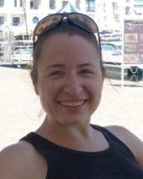  Dr Bryony Sales  GP Associate Dean Portsmouth and Isle of Wight (job share)  NHSE WTE Wessex  GP Partner and Trainer, The Portchester Practice  RCGP WPBA core group member | Having been a trainee on the Portsmouth and Isle of Wight GP training scheme Bryony joined the education team as an Education Fellow and subsequently a TPD. She became a patch Associate Dean in 2018, now job sharing with Rachel Elliott. Bryony is a GP Partner and Trainer at The Portchester Practice and a member of the RCGP WPBA core group and is passionate about medical assessments, in particular reviewing and developing the assessments on the Portfolio.  Alongside her professional roles, Bryony juggles parenthood and enjoys all aspects of living in and exploring Hampshire.
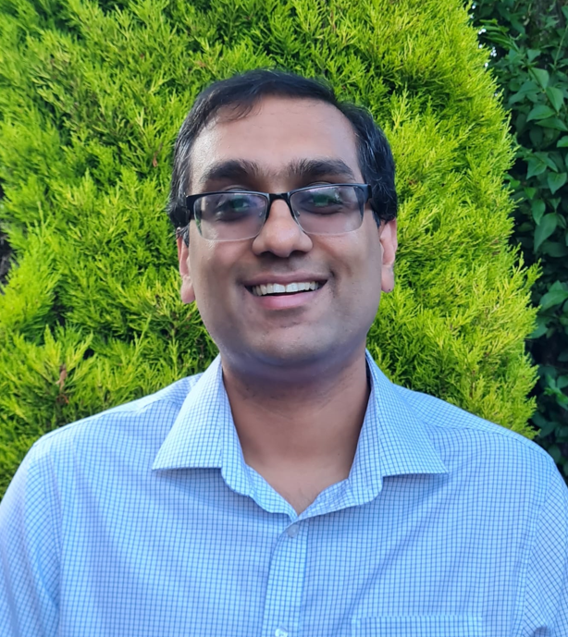  Dr. Guhavarma Viswesvaraiah  Associate Dean (Education and Development), NHS England Wessex  Consultant Acute Physician, University Hospital Southampton NHS Foundation Trust. | Guhan currently works as an Associate Dean in NHSE Wessex, being responsible for Education and Development. Guhan’s AD portfolio includes oversight of Out Of Programme (OOP) and Less Than Full Time (LTFT) applications and processes, oversight of the Fellowship programmes and Flexible portfolio training, Deanery induction, Differential Attainment as well as relocation expenses.  Guhan also works as an Acute Medicine Consultant at Southampton and continues to supervise doctors working on the Acute Medical Unit.
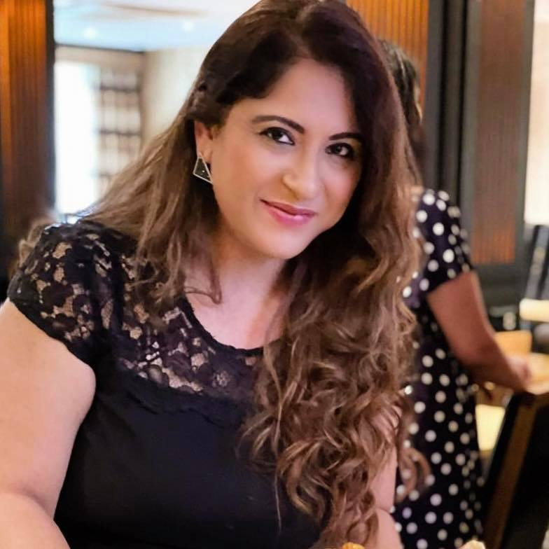  Anjali Mavi  IMG Welfare Officer  - Wessex  Hampshire and Isle of Wight Healthcare NHS Foundation Trust | Anjali is an IMG Welfare Officer under the Wessex Deanery footprint, employed by the Southern Trust. Based in Southampton, she holds an MBA degree in HR & Marketing. Anjali has extensive experience as a Community Engagement Officer and is an active volunteer dedicated to fostering cultural awareness and organizing events that celebrate diversity within the community.  For those interested in connecting with Anjali, she can be reached at Anjali.Mavi@southerhealth.nhs.uk or IMGWelfareService@southernhealth.nhs.uk.
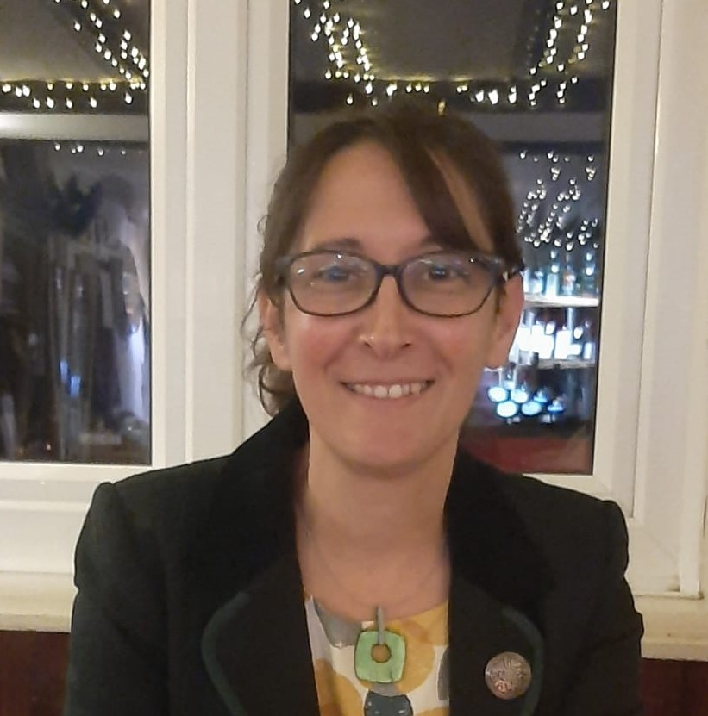  Laura Ramundo  IMG Welfare Officer  - Wessex  Hampshire and Isle of Wight Healthcare NHS Foundation Trust | Laura is an adult and children nurse with a career that began in Argentina before she immigrated to the UK in 2002. With a deep-rooted passion for health and wellbeing, she has 20 years of working for the NHS, in both acute and primary care settings.  Currently, Laura works as an IMG Welfare Officer within a small and collaborative team, covering the Wessex region. She holds a BS in Public Health from the University of Southampton; and a PGD in Children and Family Wellbeing from Oxford Brookes University. Her dedication is further demonstrated through her volunteer work in the judiciary system since 2018.  For those interested in connecting with Laura, she can be reached at Laura.Ramundo@southerhealth.nhs.uk or IMGWelfareService@southernhealth.nhs.uk.
  Professor Clare Polack  Professorial Fellow in Medical Education, University of Southampton  Southampton GP | Clare is a GP who moved to Southampton in 2004 having previously worked at Edinburgh University as a Clinical Lecturer. She has worked in Tanazania and New Zealand and has a passionate interest in Global health. Alongside her University role she works as a GP in Southampton.  In September 2011 Clare took on the role of BM(EU) programme leader. This was a new initiative to develop an undergraduate medical degree in collaboration with a German health care provider in Kassel, Germany. European students who are bilingual in German and English complete the first two years in Southampton and the remaining three (mainly clinical years) in Kassel. The first cohort of BM(EU) students graduated in 2018 and have guaranteed foundation year 1 jobs in Kassel.  Clare is chair of Student Progress Committee and leads for the Faculty on Fitness to Practice, Special Considerations and Appeals.  https://www.southampton.ac.uk/people/5x278p/professor-clare-polack#biography
Katie Castle  Education Quality Lead in Practice Learning  Workforce, Training and Education Directorate, NHS England South East | Katie is an education quality lead in practice learning for NHS England South East with a focus towards the Wessex area. She supports a multi-professional lens of quality assurance of the learning environment. Prior to her joining Health Education England in 2022, she was a programme lead of a physiotherapy programme at Winchester University and has held posts in research and improvements with Solent NHS Trust. She has experience of both NHS and private neurological physiotherapy services in London and the Midlands.
Caroline Lee  Head of Education Quality  NHS England - South East | Caroline is Head of Education Quality in the South East NHS England with a focus is the Wessex area. She works multi-professionally to assure the work based learning experience across sectors. Caroline has a background in education commissioning for clinical professions and NHS workforce planning. Prior to joining the NHS in 2005 she worked in service management in the private healthcare sector and in clinical diagnostics for immunology and biochemistry areas.
Dr Helen O'Reilly  Associate Dean, Wessex Primary care Training Hub, NHS England - South East  Clinical GP, GP appraiser and associate lecturer in medical education | Helen is Associate Dean for the Wessex Primary Care School with experience in both GP Training and Primary Care Wider Workforce development. In her other roles she is a clinical GP, a GP Appraiser and an Associate Lecturer in Medical Education at the University of Winchester.
Jessica Williams

Principal Genetic Counsellor
Wessex Clinical Genetics Service

Imogen Cummings

Post/appointments/roles

Michael Carter

Genomic Clinical Nurse Specialist
Wessex Clinical Genetics Service

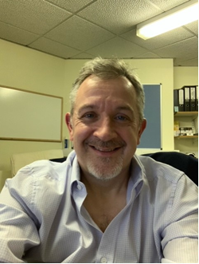  Dr Mike Masding  Co-Chair, UK Foundation Programme Office  Consultant Physician, University Hospitals Dorset NHS Foundation Trust | Dr Mike Masding is the Co-Chair of the UK Foundation Programme Office (UKFPO). He also continues his clinical work as a Consultant Diabetologist.  Mike has been involved with the Foundation Programme since its inception in the early 2000s, with workplace supervision of Foundation doctors being the subject of his MA Education dissertation at the University of Winchester in 2010. He strongly believes that good supervision is the bedrock of high quality postgraduate medical education, chairing the Education Support group in the 2019 HEE Foundation Review, and contributing to HEE’s ‘Enhancing Supervision’ work.  He feels very strongly that Foundation training should continue to be broad based, helping doctors as they make the transition from medical school and preparing them for their career in whatever specialty they may do in the future.
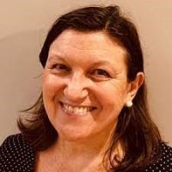  Dr Antonia Calogeras  Associate Dean, NHS England – South East  Consultant Rheumatologist UHS | Dr Antonia Calogeras is a Consultant Rheumatologist at University Hospitals Southampton NHS Foundation Trust. As well as managing the Professional Support and Wellbeing Service (PSWS), Antonia’s Associate Dean portfolio also includes SuppoRTT (Supported Return to Training).
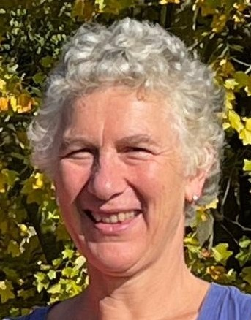  Dr Mary-Rose Shears  Primary Care Dean, Thames Valley and Wessex  NHS England – South East WT&E  GP locum, Seaford Medical Practice | Mary-Rose leads TVW primary care training and education, overseeing the GP school, Primary Care School and Training Hubs. These excellent team deliver and liaise with a range of stakeholders, including primary care providers such as General Practices, Integrated Care Systems and Higher education institutes to support the training of the right staff to meet future health care delivery needs. Central to this activity is the quality of the learning environments.  I have a particular interest in developing health professionals to enjoy and value caring for those populations traditionally less well provided for and addressing health equity. I value multiprofessional educational leadership to value our workforce and support integrated care of patients
Dr Julie Onslow

Associate Dean,
NHS England - Wessex

Professor Geeta Menon

National Clinical Lead for workforce for Cancer and Diagnostics,
National Dean for Inclusive Integrated Careers,
- NHS England – Workforce, Training and Education Directorate

Consultant Ophthalmic Surgeon
Frimley Health NHS Foundation Trust

NIHR South East Regional Research Delivery Network (RRDN) Health & Care Research Director (Medical)

