Placement profile – insert learner type
Address
Telephone number
Webpage

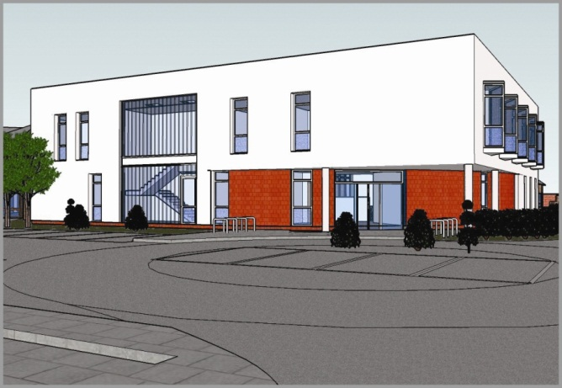

Primary Care Network information

XXX is a Primary Care Network (PCN) located in XXX. Developed in 20XX, it provides care for a local population of over 35,000 patients. Our PCN comprises of X GP surgeries, X Care Homes, X community pharmacy with a total of X GP partners, X practice nurses, etc.

Your placement will be overseen by XXX and XXX and will follow the guidance as established by relevant healthcare regulators.

Initial induction will take one day with the XXX followed by one-to-one observation with one of the XXX. At that time, you will be able to view our PCN handbook and our protocols and procedures relevant to your placement with us.

We also have a library containing educational material and internet access for online learning available throughout your time at the practice.

Your rota will be made available to you two weeks before you join us, and you will know at that time which clinics you will be observing and which clinician you will working with.

Please look at our website XXX to familiarise yourself with our team and the services we provide.

Clinical practice in a GP surgery is extremely varied and is centred on preventative care. Below is a list of some of the procedures, examinations, or consultations you may experience during your time in General Practice:
- Lifestyle advice and counselling
- NHS health checks
- New patient checks
- Weight management
- Smoking cessation advice
- BP monitoring
- Asthma clinics
- COPD clinics
- Diabetes management
- Cytology
- Child immunisations
- Travel immunisations
- B12 injections
- ECG
- Doppler
- Flu immunisation clinics
- Pneumo immunisation clinics
- Shingles immunisation clinics
- Dressings care
- Wound care
- Learning disability checks
- Mental health checks
- Contraception services
- Phlebotomy
- Triage clinic

We would like you to spend time in all areas of the PCN during your placement and our induction plan will accommodate this. We would also like you to spend time with all other PCN support teams so you can understand the processes in place to ensure continuity of care and how healthcare is managed in the community.

If you have any questions, please contact XXX.

