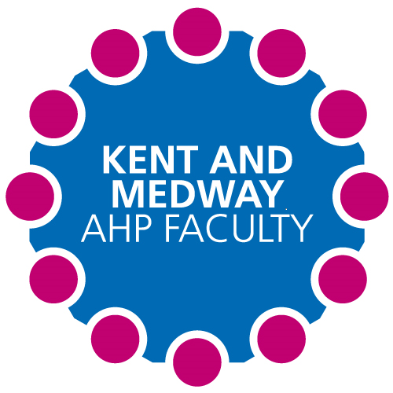

**Kent and Medway AHP Faculty Newsletter**

Issue No. 5 September 2021

**Bitesize Training:**

15th October- Practice educator conference: Kent county showground

18th October – CCCU to demonstrate SharePoint the new student placement allocation process.

26th October - 9.15-10.30- Kent, Sussex and Surrey will be discussing student placement allocation and student placement models.

For further information and a MS Team invite please email [rebecca.taplin@nhs.net](mailto:rebecca.taplin@nhs.net)

**The Faculty would like to hear your voice:**

The Kent and Medway AHP Faculty was set up to support collaborative working across the system between health and social care providers and higher educational institutes to improve the AHP workforce.

If you would like to attend a Faculty meeting as a guest please contact [rebecca.taplin@nhs.net](mailto:rebecca.taplin@nhs.net) for an MS Team invite and further information.

**OT student placement timeline**

In collaboration with CCCU and the OT services across Kent and Medway an OT Student placement allocation timeline has been produced to improve the coordination of student placements.

***Alternate Mondays and Thursdays 2pm-3pm via ZOOM***

Are you an AHP Practice Educator in Kent and Medway? Do you currently supervise students or are interested in doing so? Nicki and Iain (Student Placement Expansion Facilitators) would like to invite you to our Practice Educator Network! Come and connect with other AHP Practice Educators in Kent and Medway in a supportive network and share experiences and ideas. Here are the dates and topics for the next 6 months:

**Thursday 7th October 2pm-3pm- “What’s in it for me?”**

Discussion around benefits of taking students for the workforce, your service & yourself

**Monday 15th Nov 2pm-3pm- “Multi-student models”**

Learn about Peer learning/multi student models & how you could implement them, their benefits & some potential drawbacks

**Thursday 6th Jan 2pm-3pm – “AHPs- We are all different”**

Learn about the difference in various AHP placements, their impact & how they may benefit your service

**Monday 14th Feb 2pm-3pm – “Remote/TECS placements”**

Discussions around various TECS placements including fully virtual & hybrid models, their benefits & how they impact you & the student

**Thurs 31st March 2pm-3pm- “Coaching struggling students”**

Tips & discussions around managing students who are struggling or may need additional input

We look forward to seeing you there. To be added to the mailing list for a Zoom invite,

please email either Nicki ([**nicki.mcrae@nhs.net**](mailto:nicki.mcrae@nhs.net)) or Iain (iain.spink@nhs.net)