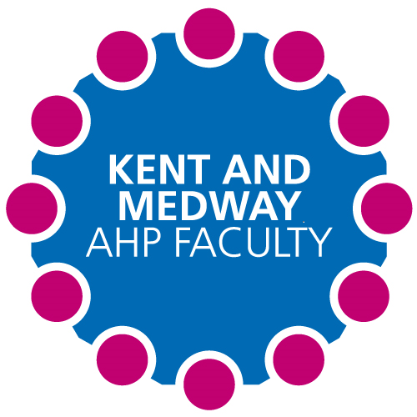

**Kent and Medway AHP Faculty Newsletter**

Issue No. 1 June 2021

**The Kent and Medway Faculty**

**What is the Faculty:**

This AHP faculty will be a group of health, social care organisations and education and training providers that formally work together across the Kent and Medway STP, to support and deliver a collective approach to addressing the AHP workforce.

**Who Are we:**

Kent and Medway CCG / Dartford and Gravesham NHS Trust / East Kent Hospitals University NHS Foundation Trust / Kent Community Health NHS Foundation Trust /Kent and Medway NHS and Social Care Partnership Trust / Maidstone and Tunbridge Wells NHS Trust / Medway NHS Foundation Trust / Medway Community Health Care Trust / South East Coast Ambulance Service NHS Foundation Trust / Virgin Care / Kent County Council / University of Brighton/ University of Surrey/ Canterbury ChristChurch Univerity/ Private Providers. Health Education England/

Supporting the newly qualified AHPs entering employment within Kent and Medway Health and Social Care Providers:

The Kent and Medway AHP Faculty are collaborating with Canterbury Christ Church University to produce a pre preceptorship programme to support the transition from education to the workplace.

**PEARL Awards**

(Practice Educator Award for Reimagining Learning)

**PEARL Award May Winner(s):** Anna Hargrave: KMPT Specialist Neurological Physiotherapist

**Placement Information:**

1/3/21 for 6 weeks

Split clinical and leadership placement.

**Why was it Innovative?**

**The placement was a mix of clinical with Anna, whilst the rest was a leadership placement within the Kent and Medway AHP Faculty. Anna had not had a student in a very long time, but still agreed to help facilitate this unique placement. She helped develop clinical skills, whilst also helping the student to juggle 2 leadership projects remotely. This placement allowed more than one part-time AHP to be involved in facilitating, demonstrating that part-time staff can indeed help to take students.**

Kent and Medway ‘On demand’ AHP virtual work experience

This is a funded Programme from Health Education England (HEE) across the South East region. This program offers 10 hours of virtual work experience across the 14 allied health professions (AHP).

Each ICS will be allocated 400 entries onto the program. Of these allocations 250 will be allocated by Springpod to schools and Colleges within your area. The remaining 150 allocations will be available for each organisation to use throughout the year. These allocations can also be advertised in external setting, eg Job Centre’s, gyms.

For a student that is at school or college:

<https://www.springpod.co.uk/experience/allied-health-professional-on-demand>

For a college lever/ Adult:

<https://join.springpod.co.uk/ahp-on-demand-adult-learning-course/>