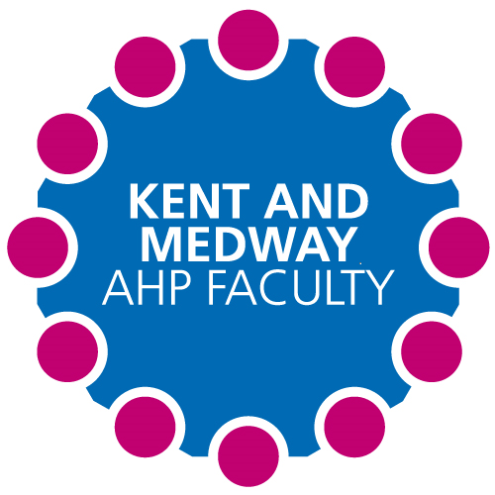

**Kent and Medway AHP Faculty Newsletter**

Issue No. 3 July 2021

The conference will be held at Detling show ground on Friday 15th October 2021 and the aimed audience is AHP Practice Educators.

The growth and sustainability of the Allied Health Professional workforce is a national directive from Health Education England linked to the ambitions of the NHS Long Term Plan.

**PEARL Awards**

(Practice Educator Award for Reimagining Learning)

**PEARL Award June Winner(s):** Nicola Gratus: Art Psychotherapist

**Placement Information:**

October 2020 to October 2021

**Runner(s) Up:**

Julia Earle and Hayley Freeman

**'Make it Work: Supporting AHPs Transition to the Workplace' - A Pre-Preceptorship Programme**

The Kent and Medway AHP Faculty in collaboration with CCCU are producing an e-learning program for newly qualified AHPs to support them transition from education into employment. This program will be hosted by E-Learning For Health and will be launched later this year.

**Student Placements Expansion Project**

Kent and Medway AHP Faculty received funding from Health Education England to increase student placements across Kent and Medway for all Allied Health Professions. A team was appointed with the aim to improve collaboration across the system and improve working relationships between higher education institutes and health and social care providers. The sharing of good practice and new ways of working helped to increase student placement capacity.

The number of student placements has increased by 248 this year. This is an increase of 21 per cent during 2020 and 2021.

We would like to say a big thank you to all our AHP practice educators who have helped us achieve this.

**Growing the Future Workforce: Kent and Medway AHP Practice Educator Conference**

**Registration is now open:**

<https://thinkdifferent.eventscase.com/EN/AHPConference/Register>

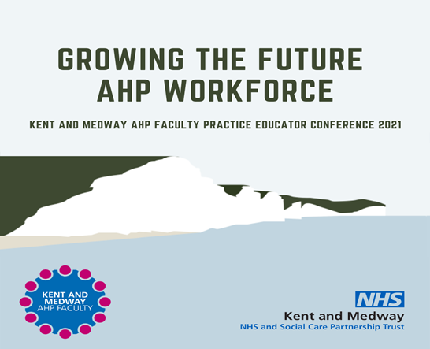

This conference will bring together Practice Educators from all 14 Allied Health Professions within Kent and Medway. It will highlight the crucial work of AHP’s in providing training opportunities for our future AHP workforce. It will showcase best practice, provide networking opportunities, peer support and learning for AHP Practice Educators. We will also hear directly from our future AHP workforce through student representation.